Project Documentation
1. Introduction
Project Title: Product Inventory Management System
Skill Wallet Team id: SWTID-2026-3953
Team Leader: SABARINATHAN S (sabarish2006pc@gmail.com)

Team Members:
- PRAVEENRAJ M(praveenpraveen9919@gmail.com)
- SRIDHAR K (sumathi2142003@gmail.com)
- SANJAY KUMAR (shyamsanjay0077@gmail.com)

Roles and Responsibilities:

Team Leader – SABARINATHAN S
Oversees project progress and task allocation.
Coordinates team communication and final integration.
Ensures timely submission and quality of deliverables.
Team Member – SRIDHAR K
Database management system for the project.
Team Member – PRAVEEN RAJ M
Making the project documentation and gathering the new ideas.
Team Member – SANJAY KUMAR
Project testing and debugging the coding errors.

Product Inventory Management System

PROJECT OVERVIEW
The Product Inventory Management System is a backend-focused web application developed using Node.js, Express.js, and MongoDB, designed to provide a secure and scalable solution for managing product data through RESTful APIs. The system enables users to create accounts, log in securely, and access protected routes using JWT-based authentication, ensuring that only authorized users can perform operations. It supports complete CRUD functionality, allowing users to add new products, view their inventory, update product details such as price or quantity, and delete items when needed.
Key Objectives:
- Provide secure JWT-based user authentication and authorization for protected API access.
- Enable efficient product inventory management through RESTful CRUD operations.
- Ensure user-specific data isolation so each user can manage only their own products.
- Implement scalable backend architecture using Node.js, Express.js, and MongoDB.
- Deliver fast and reliable API responses with proper validation and error handling.
Target Users:
- Small business owners managing product stock and inventory records.
- Freelancers or sellers tracking items or services in a structured way.
- Developers learning backend API development and authentication workflows.
- Students working on backend or full-stack development projects.
- Anyone needing a secure and simple backend system for managing product data.

PROJECT INSTRUCTION
- Create backend project folder
- Configure server using Express.js
- Setup MongoDB database connection
- Implement authentication APIs
- Implement product CRUD APIs
- Test APIs using Thunder Client in VS Code

PRE-REQUISITES
Software | Purpose
Node.js | JavaScript runtime for backend
MongoDB | Database storage
npm | Package manager
VS Code | Development environment

Knowledge Requirements
- JavaScript ES6 concepts
- Node.js and Express.js REST API development
- MongoDB and Mongoose ODM
- JWT authentication
- Middleware architecture
Project Thumbnail:
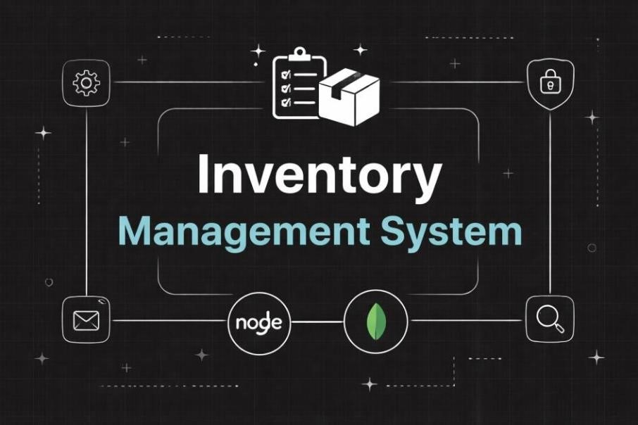

PROJECT ARCHITECTURE
High-level architecture diagram illustrating the three-tier backend structure.
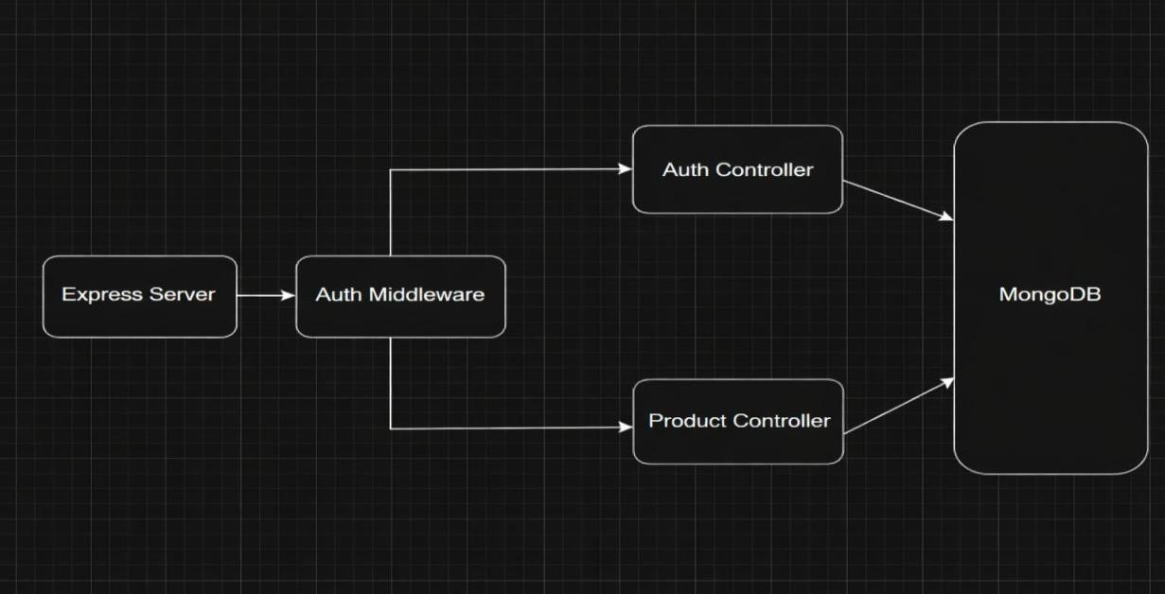

•

RESTful API architecture

Node.js + Express Backend

- JWT authentication middleware
- MVC pattern (Models, Controllers, Routes)
- Input validation and error handling
MongoDB Database
- Document-based NoSQL storage
- Mongoose ODM for schema modeling
- Two collections: Users and Contacts
- Indexed fields for optimized queries

TECHNICAL ARCHITECTURE
Backend Architecture (Node.js + Express)
- Controllers: Handle authentication and product logic
- Models: Define database schema
- Routes: API endpoints for authentication and products
- Middleware: JWT verification and error handling
- Configuration: Environment variables and database connection

Database Architecture (MongoDB)
Users Collection:
- _id
- name
- email
- password (hashed)
- timestamps
Products Collection:
- _id
- userId (reference to user)
- name
- price
- quantity
- description
- timestamps
Relationship: One User → Many Products
Indexes:
- email (unique)
- userId
- product name

ER Diagram
ER diagram showing User → Product relationship:
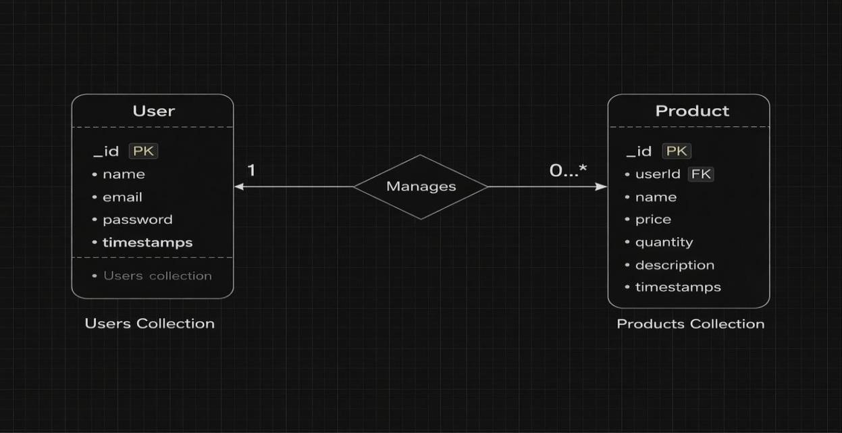

Features:
Core Features
S.No | Feature | Description
1 | User Authentication | JWT-based register and login system
2 | Product CRUD | Add, view, update and delete products
3 | Private Data Access | Users access only their own products
4 | Product Search | Search products by name
5 | Secure API | Middleware protected routes

Roles and Responsibility

User
Registration: Register using name, email and password
Login: Login using registered credentials
Add Product: Create product with name, price, quantity and description
Edit Product: Update existing product
Delete Product: Remove product from inventory
Search Product: Search products using keyword User Flow
- The user sends a register/login request.
- The backend generates a JWT token.
- The user sends a token in the Authorization header.
- Middleware verifies the token.
- The controller performs CRUD operations.
- MongoDB stores or retrieves product data.
- API sends response.

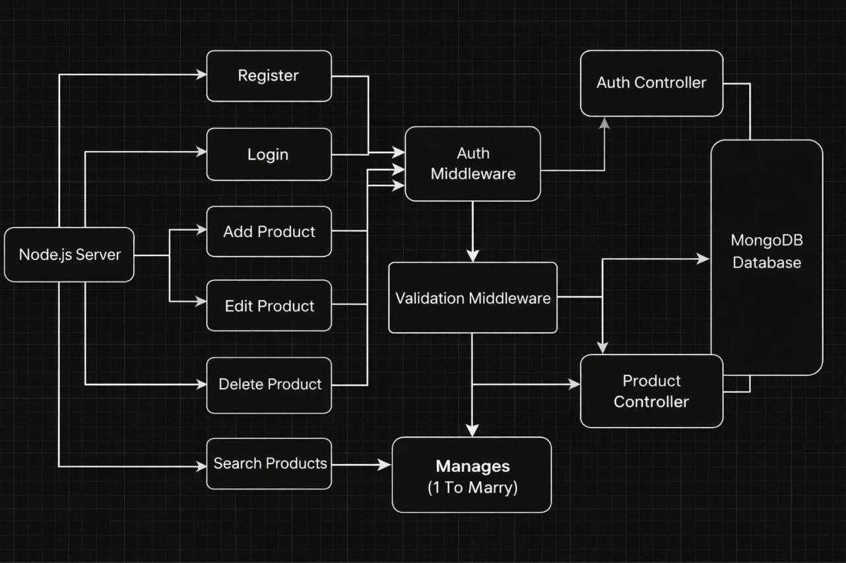

Project Setup and Configuration

Folder Structure

server/
│
├── node_modules/
├── src/
│ ├── controllers/
│ ├── db/
│ ├── middlewares/
│ ├── models/
│ ├── routes/
│ └── server.js
│
├── .env
├── .gitignore
├── package-lock.json
└── package.json

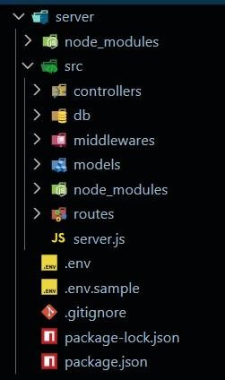
Initialize Node.js Project:
Open terminal inside the server folder and run:
npm install
This creates the package.json file which manages project dependencies.

Install Required Packages:
Install backend dependencies:
npm run dev

Package Purpose:
- express → Backend framework
- mongoose → MongoDB connection
- cors → Cross-origin requests
- dotenv → Environment variables
- jsonwebtoken → Authentication
- bcryptjs → Password hashing
Create Environment File:
Create a .env file in the root of the server folder.
Example:

PORT=5000
MONGO_URI=your_mongodb_connection_string JWT_SECRET=your_secret_key

Backend Development

Setup Express Server:
Inside src/server.js, create the basic Express server.
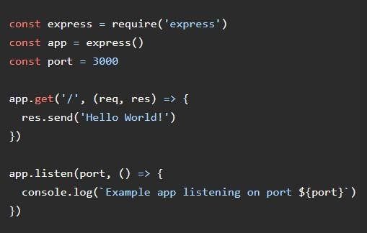

Create Controllers Inside:
src/controllers/ Create: auth.controller.js

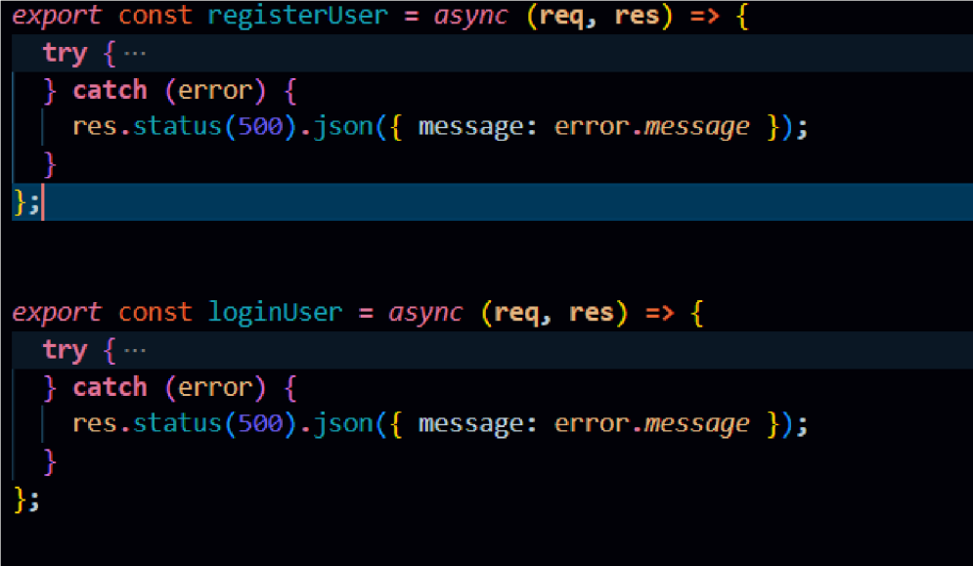

Auth Controllers
The Auth Controller manages all user authentication-related operations in the system. It handles user registration and login functionality while ensuring secure access using JWT tokens.
Responsibilities:
- Register new users
- Validate user input data
- Hash passwords using bcrypt before storing
- Authenticate users during login
- Generate JWT tokens for authorized access
- Send appropriate success and error responses
Main Functionalities:
- Register User: Creates a new user account after validating email uniqueness and encrypting the password.
- Login User: Verifies credentials and returns a JWT token for protected API access.

product.controller.js
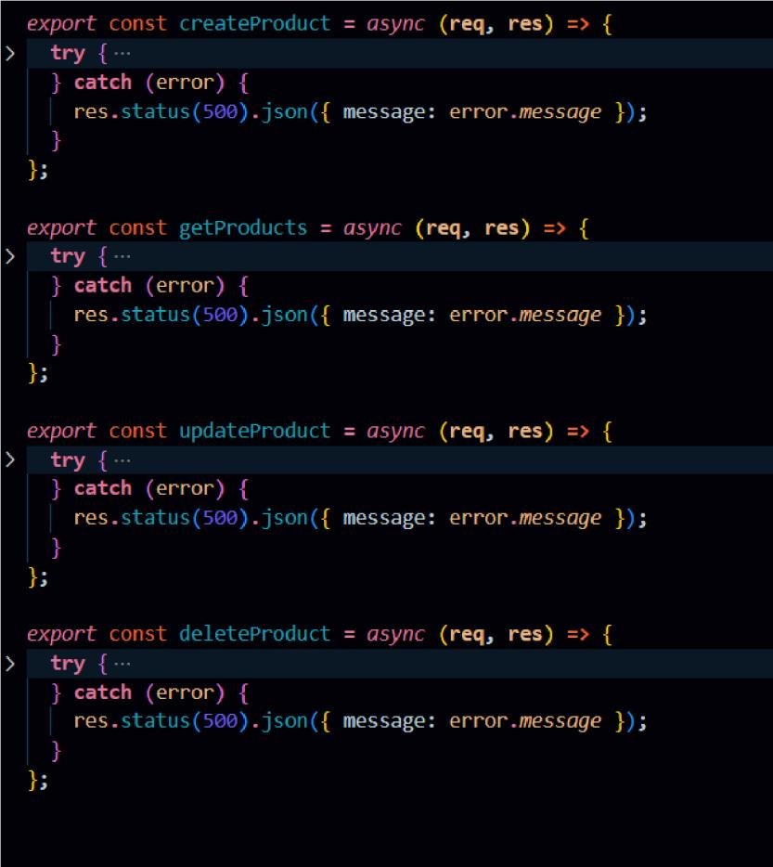

Product Controller
The Product Controller handles all product inventory operations and contains the business logic for managing products linked to individual users.
Responsibilities:
- Add new products to inventory
- Fetch products belonging to logged-in users
- Update product details like price, quantity, or description
- Delete products securely
- Perform product search functionality
Main Functionalities:
- Create Product: Adds a new product with a reference to the authenticated user.
- Get Products: Retrieves only the products created by the logged-in user.
- Update Product: Modifies product details while verifying ownership.
- Delete Product: Removes a product safely from the database. ● Search Product: Allows filtering products based on name. Create Middleware
Inside: src/middlewares/

Create:auth.middleware.js
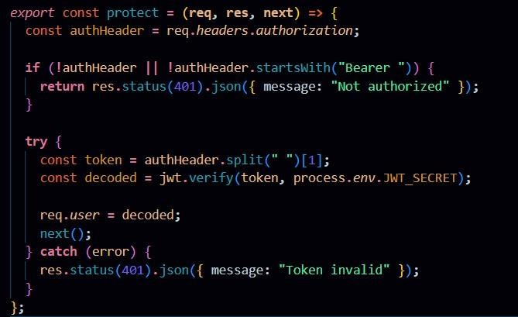

Auth Middleware (protect)
The Auth Middleware secures protected routes by verifying the JSON Web Token (JWT) sent in the request header. It checks for a valid Authorization header starting with "Bearer " and validates the token using the secret key. If the token is valid, the decoded user information is attached to req.user and the request proceeds to the next controller. If the token is missing or invalid, the middleware returns a 401 Unauthorized response, preventing access to private APIs.
Create Routes
Inside: src/routes/

Create:

auth.routes.js

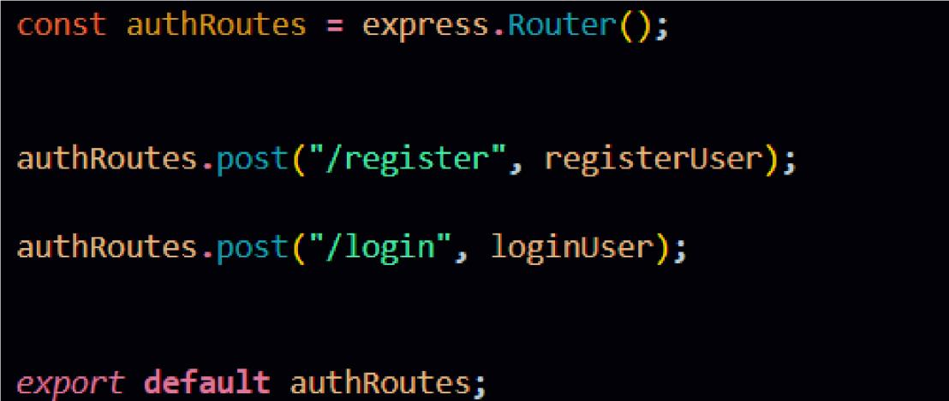

Auth Routes:
Auth routes handle user authentication by providing endpoints for registration and login. These routes connect incoming requests to the Auth Controller to create new users and generate JWT tokens for secure access.

product.routes.js

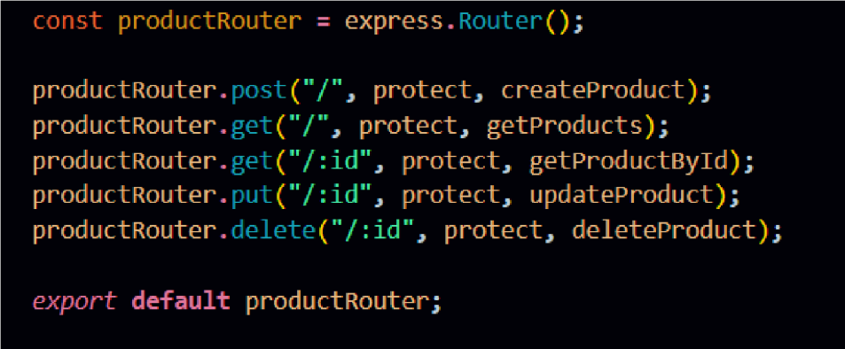

Product Routes:
Product routes manage all inventory-related operations such as creating, retrieving, updating, and deleting products. These routes are protected using authentication middleware to ensure only authorized users can access their own product data.

Connect Routes to Server

Import all routes into server.js
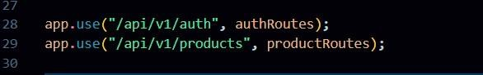
These route configurations connect the authentication and product APIs to the main Express server using versioned endpoints. The /api/v1/auth path handles all user authentication requests, while /api/v1/products manages product-related operations, helping maintain a structured and scalable API architecture.

Database Configuration and Setup
- Create MongoDB Atlas cluster ● Add connection string to .env ● Connect DB before API testing.
Database Connection:
Create a file inside: src/db/db.js
Purpose: Connect backend to MongoDB using mongoose.
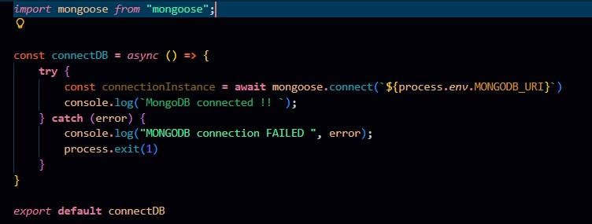
The connectDB function establishes a connection between the application and MongoDB using Mongoose and environment-based configuration. It ensures the server starts only after a successful database connection and logs an error message if the connection fails.

Create Models:
Inside src/models/ create: ●
User.js
- Product.js

User Model:
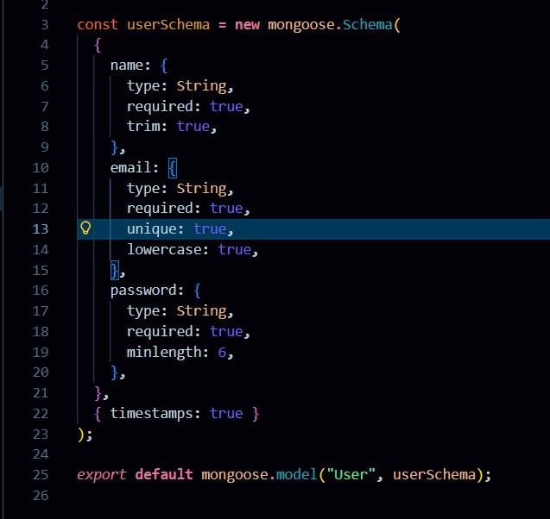
User Schema:
The User schema defines the structure for storing user details such as name, email, and hashed password in the database. It supports secure authentication and maintains timestamps for record tracking
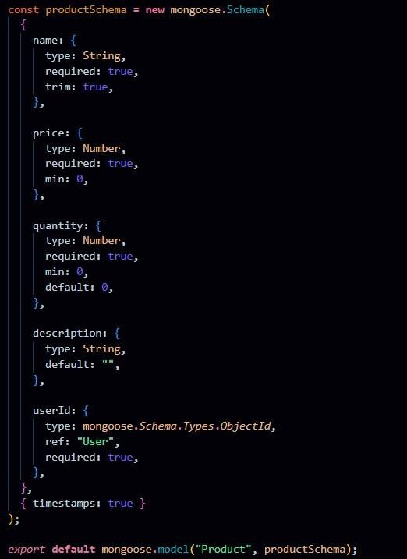

Product Schema:
The Product schema represents inventory items and includes fields like name, price, quantity, description, and a userId reference. It ensures each product is linked to its owner, enabling private data access and management.

Project Execution

Execution Steps 1. Open terminal in server folder.
- Make sure you have a start script in the package.js file.
- Run:
npm start

3. Console should display:
Server running on PORT
Database Connected

API Testing :
Use Thunder Client to test APIs:
Test APIs:
Register User:
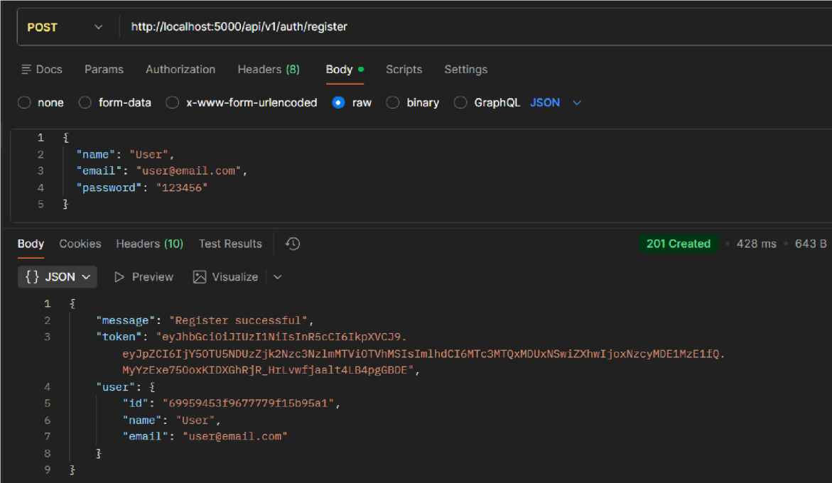
Register:The register functionality allows new users to create an account by submitting their details, which are validated and securely stored with a hashed password. It ensures unique user creation before granting access to the system.
Login User
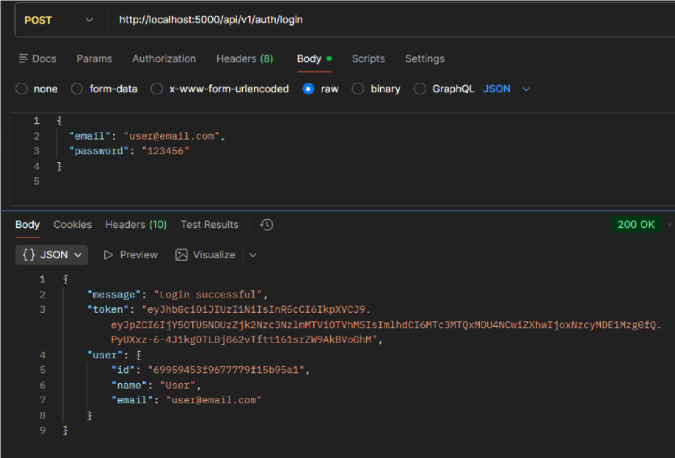

Login:
The login functionality verifies user credentials and generates a JWT token upon successful authentication. This token is used to access protected routes securely.
Create Product
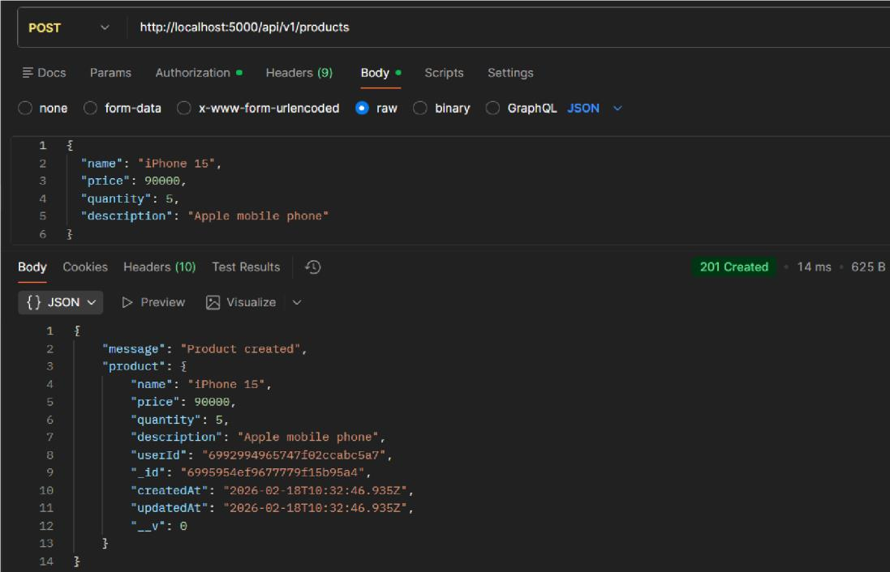
Create Product:
Allows an authenticated user to add a new product to their inventory by submitting product details. The product is saved with the user’s ID to maintain ownership.

Get all Products
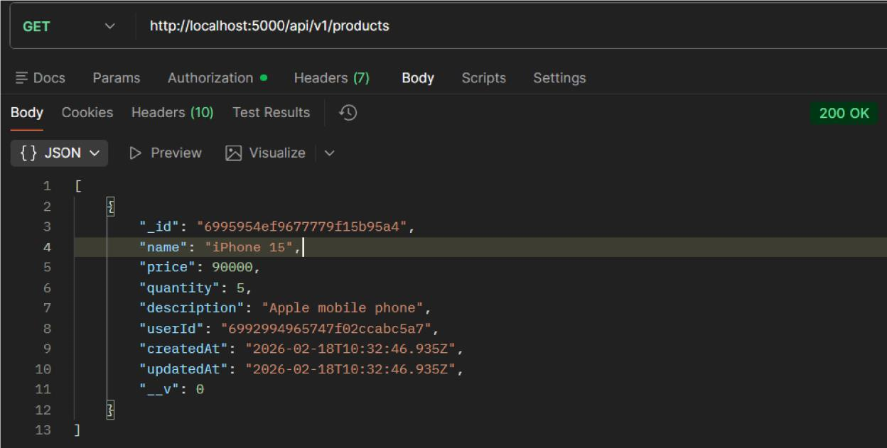
Get all Products:
Fetches all products that belong to the logged-in user. It ensures users can view only their own inventory data.

Update Product
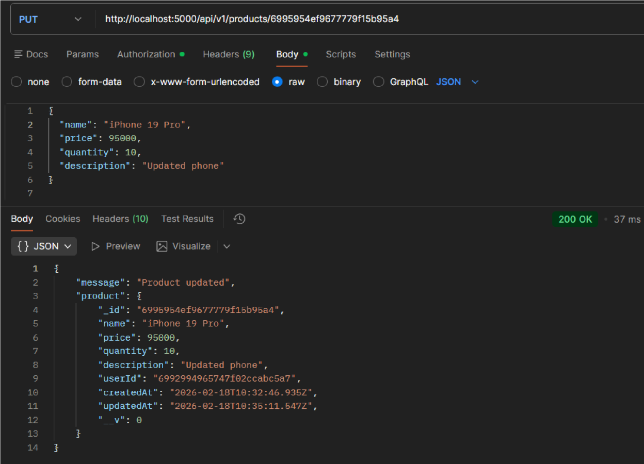
Update Product:
Enables users to modify existing product details such as name, price, or quantity. The system verifies ownership before allowing any updates.

Delete Product
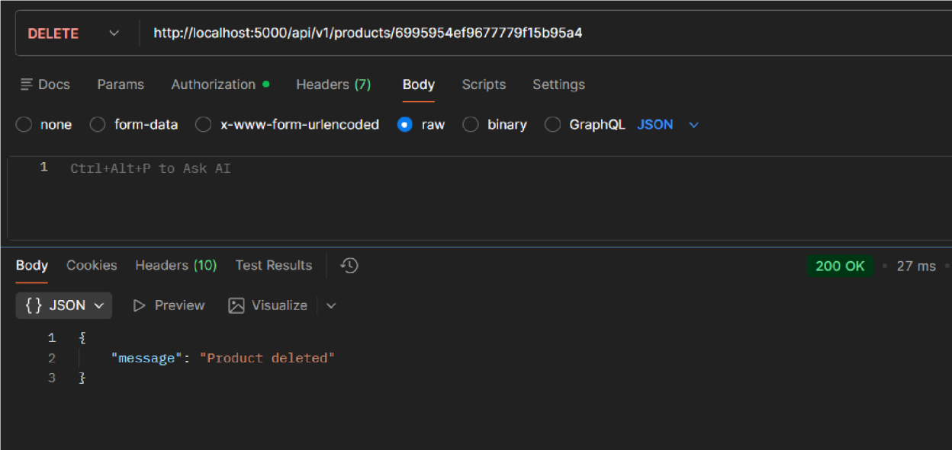
Delete Product:
Allows users to permanently remove a product from their inventory. The operation is protected to ensure only the product owner can delete it.

